

Department of Computer Engineering

Hope Foundation’s

International Institute of Information Technology

Hinjewadi, Pune – 411057

Semester-I (AY 2020-2021)

**BUS RESERVATION SYSTEM**

A Mini Project

Submitted by

Shreyas Chavhan (SC 55)

Shreeyash Borse (SC 53)

Atharva Deshpande (SC 16)

SECOND YEAR COMPUTER ENGINEERING

**Abstract** :

Traveling is a large growing business across all countries. Bus reservation system deals with maintenance of records of details of each passenger. It also includes maintenance of information like schedule and details of each bus. To maintain records of passenger details, seat availability, price per seat, bill generation and other things, we are offering this proposal of computerized reservation system. By using this software, we can reserve tickets from any part of the world, through telephone lines, via internet. Customer can check availability of bus and reserve selective seats.

The project provides and checks all sorts of constraints so that user does give only useful data and thus validation is done in an effective way.

**Introduction :**

Our project is to computerize traveling company to manage data, so that all the transactions become fast and there should not be any error in transaction like calculation mistake, bill generation and other things. It replaces all the paper work. It keeps records of all bills also, giving to ensure 100% successful implementation of the computerized Bus reservation system.

**Software and Hardware Details :**

Recommended Operating System : 64 bit windows or Open Source Linux or its derivatives.

Recommended Programming Tools : Open Source Programming Tools like G++/GCC, C++ IDE (Visual Studio Code or any other).

**Libraries/Packages Used :**

Some header files used in the project are:

1) **<iostream> :** The C++ <iostream> header file declares a set of functions Input/Output. It also defines I/O stream objects such as cin, cout , clog, etc.

2) **<iomanip> :** <iomanip> is a library that is used to manipulate the output of C++ program.

3) **<string.h> :** It is the header file required for string functions and handling. It defines one variable type and various functions for manipulating arrays of characters.

**Source Code :**

Some of the functions used in the code along with their functionality are :

1**) bus_no()** : This function is used to add a new bus . It takes the inputs like bus number, driver’s name and some more important details.

2) **book_seat()** : This function is used to reserve the seat in the bus among the available non-empty seats.

3) **display()** : This function is used to display the all the reserved as well as non-reserved seats in the bus.

**Output:**

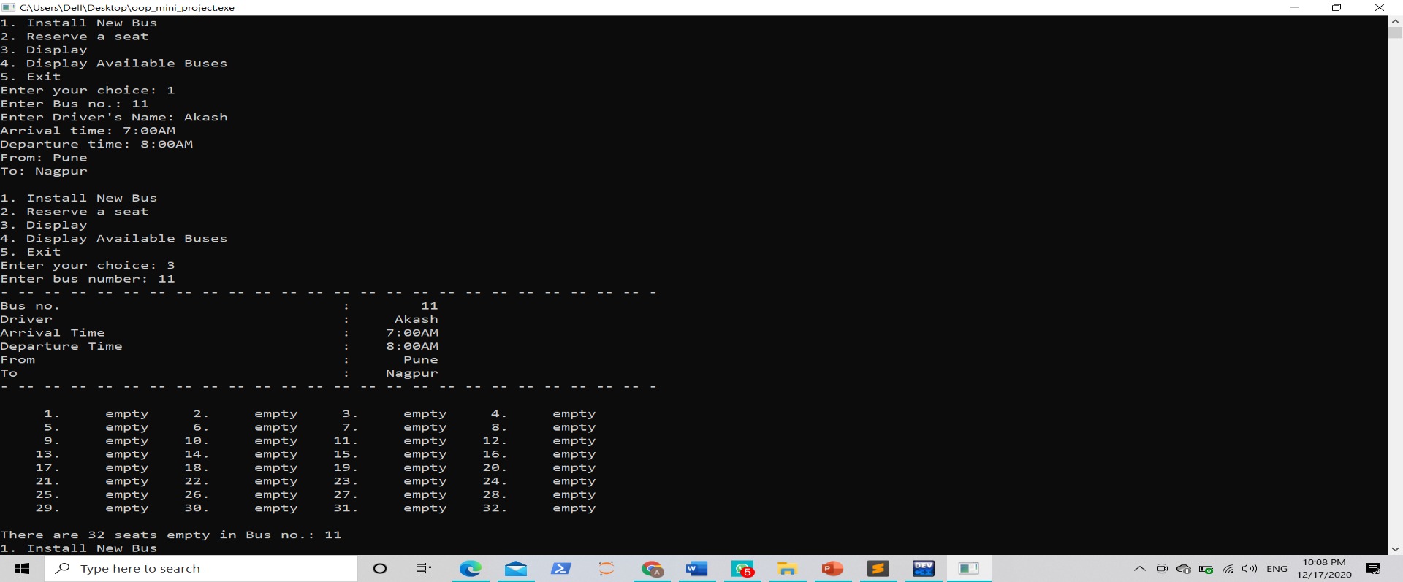

The output after installing a new bus.

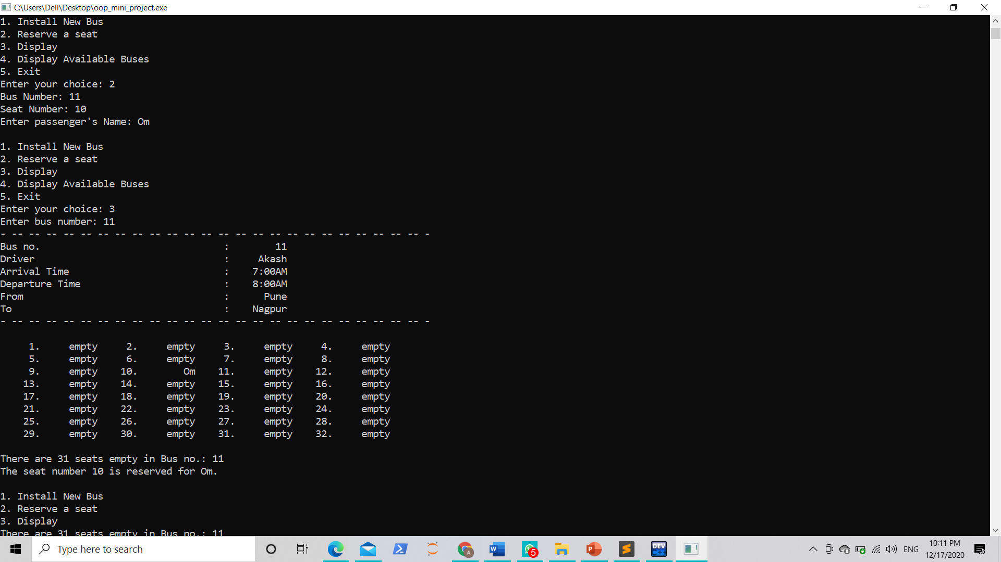

The output after reserving a seat.

**Conclusion :**

The bus reservation system has been designed by object-oriented methods. Our approach involves the use of object-oriented methods and Semantic Analysis Patterns. By using OOP, we recap the general benefits of this approach, i.e. reusability, extensibility, and conceptual abstraction. The use of 3D arrays made the implementation of the algorithm quite easy.